PF LAB 3 ASSIGMENT

(C LANGUAGE)

## Question 1:

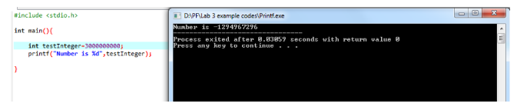

It produces wrong value due to the integer format we set for 30000000, integer format cn only store 4 bits so it outputted a garbage value. We have to use long long int.

## Question 2:

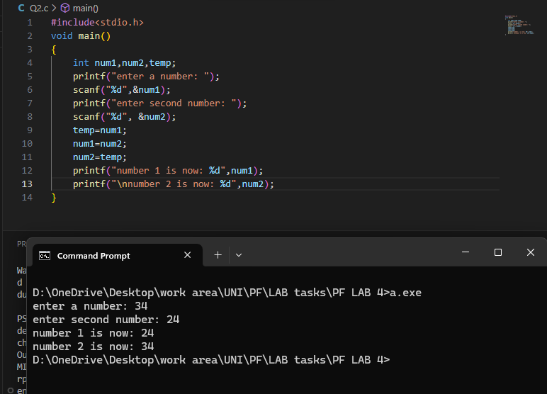

## Question 3:

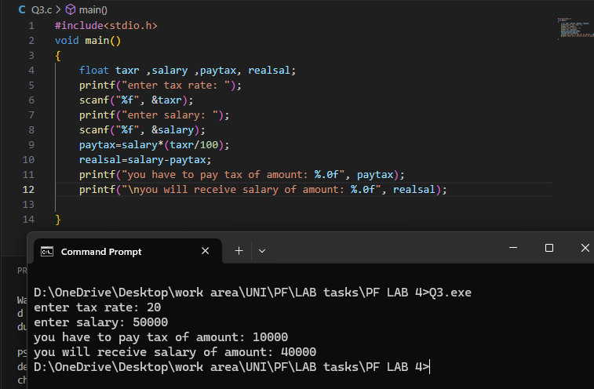

## Question 4:

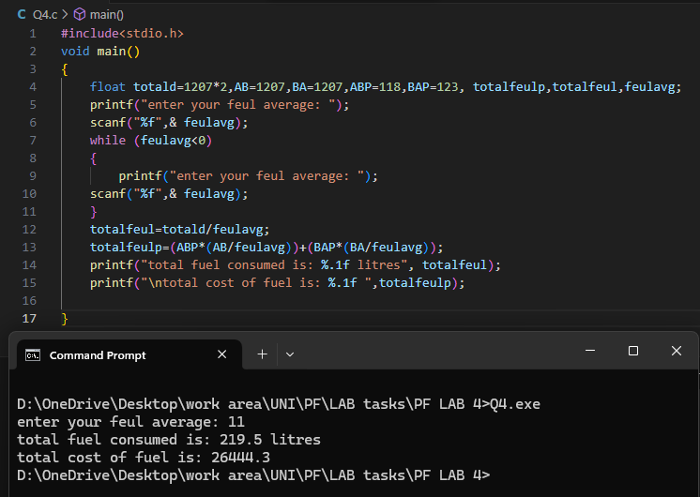

## Question 5:

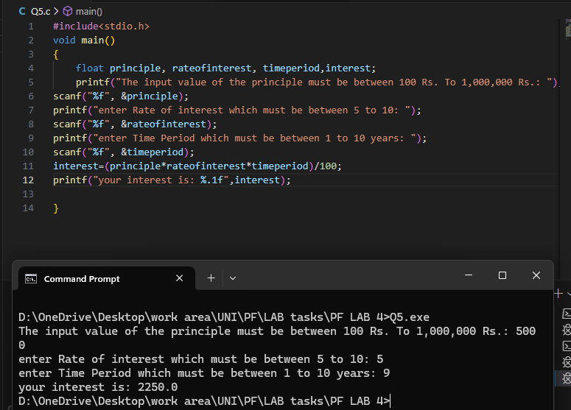

## Question 6:

